**Subnetting**:

* Group of ips is called subnetting
* We can group the entire network into smaller parts
* Subnet mask will help us to get this done
* Subnetting is dividing a big network into smaller parts as it is easy to manage smaller network and we can provide security to network
* For a single big network, it involves 3 steps to reach where as in subnetting, it involves 4 steps. That is the disadvantage of subnetting
* Because, here first we need to reach the network, then to subnet, after that we need to reach host and then process. So, it involves 4 steps process

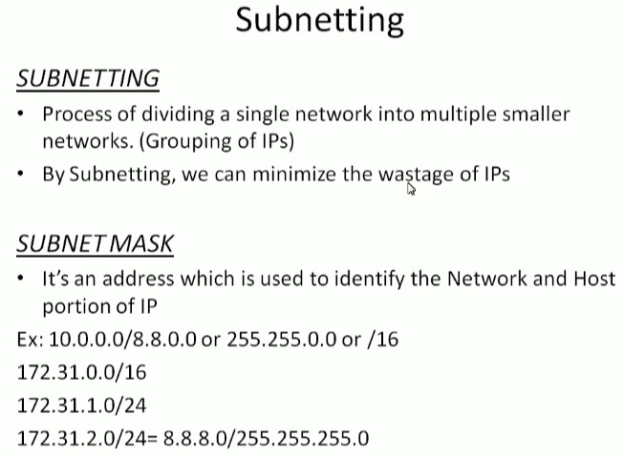

* /16 or 8.8.0.0 means it is registered the first two octates for network and remaining for hosts
* Subnetting is used to break down the network and treat them as different networks

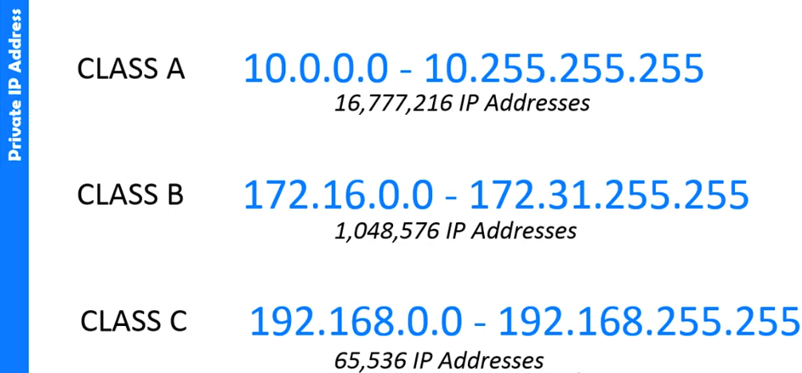

* These are the private IP addresses

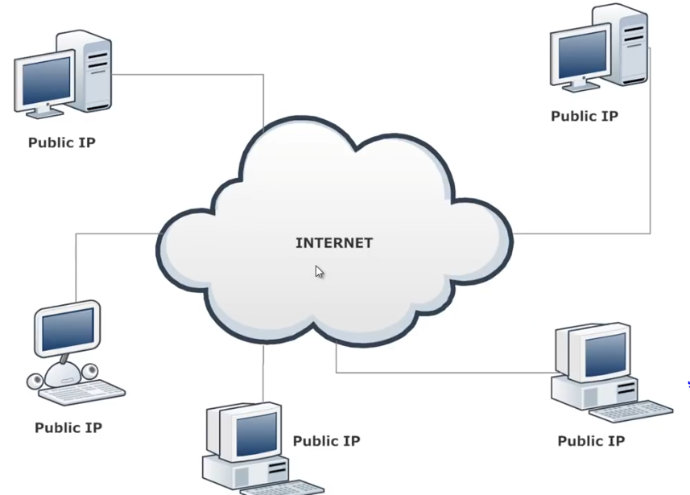

* Subnetting is class less networking (CIDR Class less Inter Domain Routing)

**Dividing subnetting groups:**

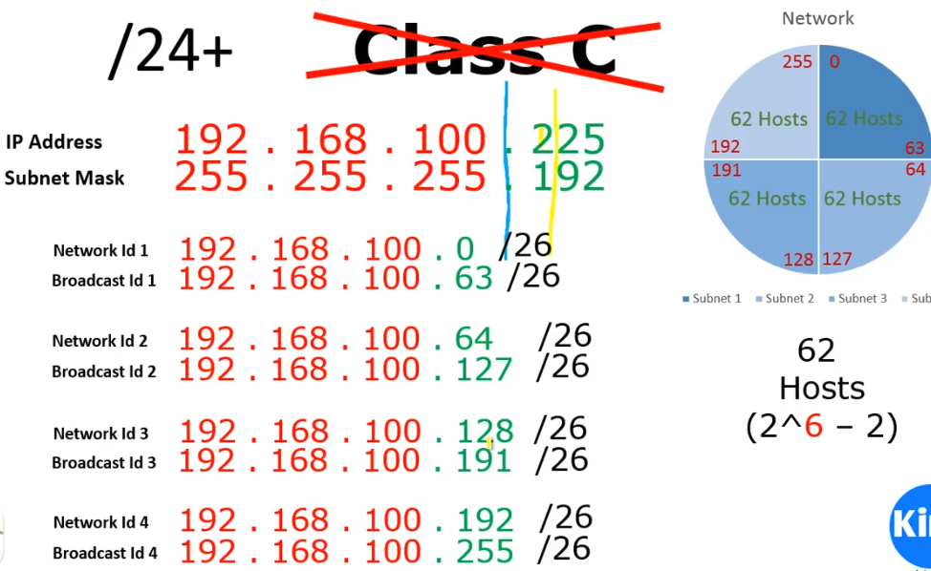

* This is how it looks like if we divide with 2 bits for 4 networks. As we borrowed 2 bits from host. So, it will be /26
* Below is the subnet table for class C

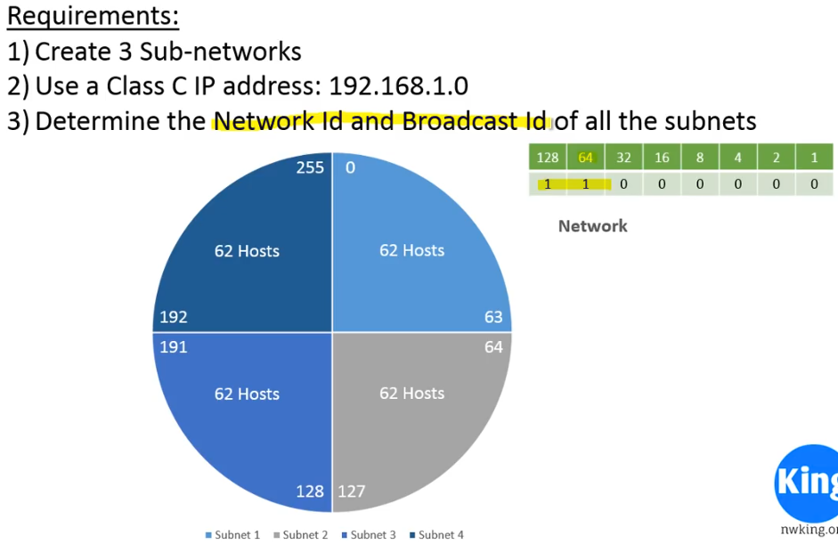

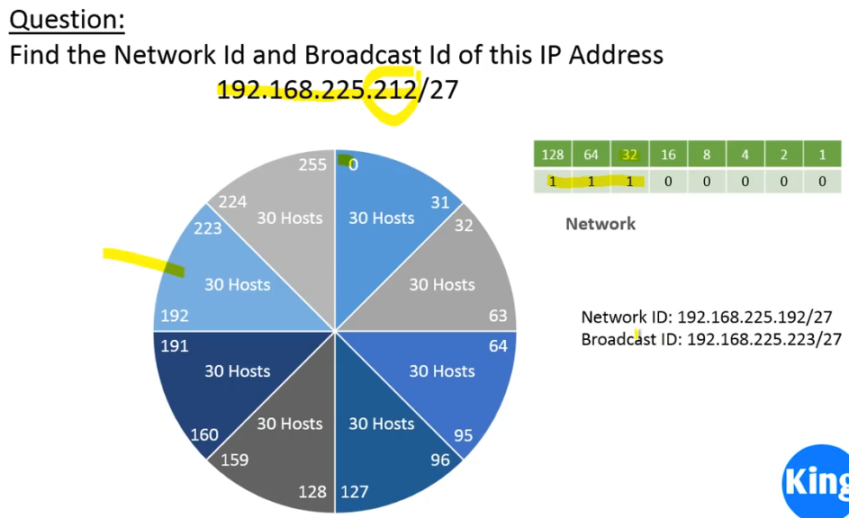

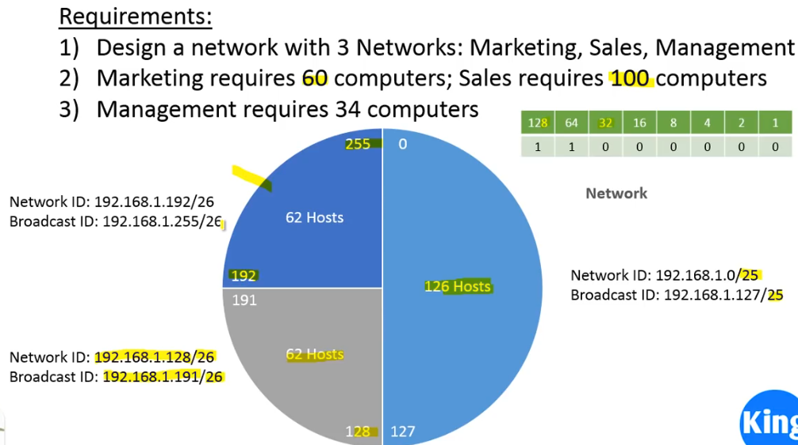

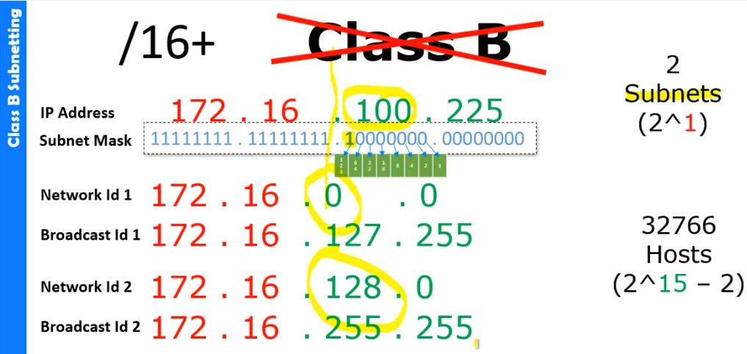

* We borrowed 1 bit which means /17 here

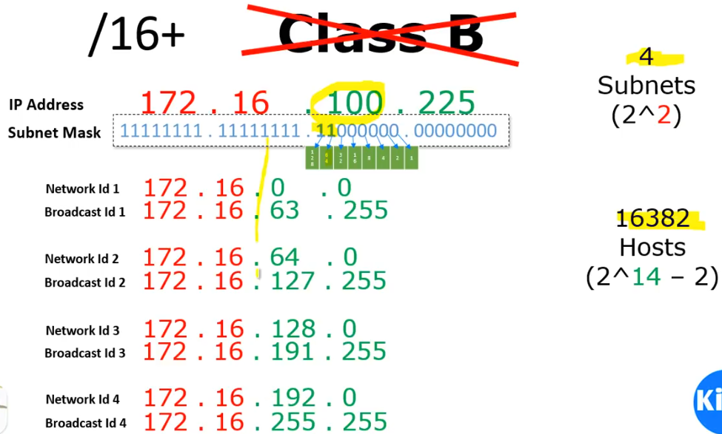

* Another example of dividing class B into 4 subnets. To get broadcast ID, we need to do -1 from next network ID
* We borrowed 2 bits. So, it is /18

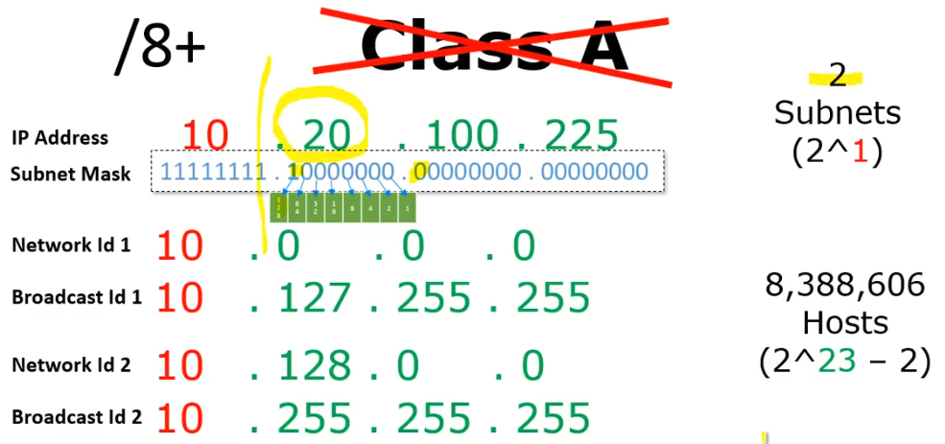

* Class A subnetting as above. It will be as /9

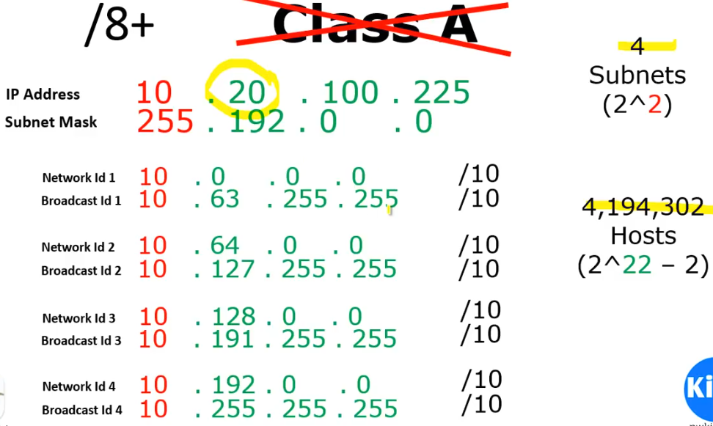

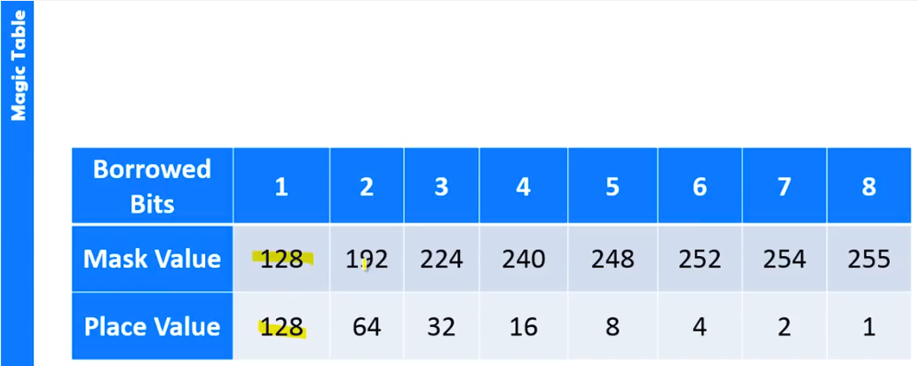

* For example, the IP is 200.1.2.0 which means class C, it is 24 network bits and 8 host bits

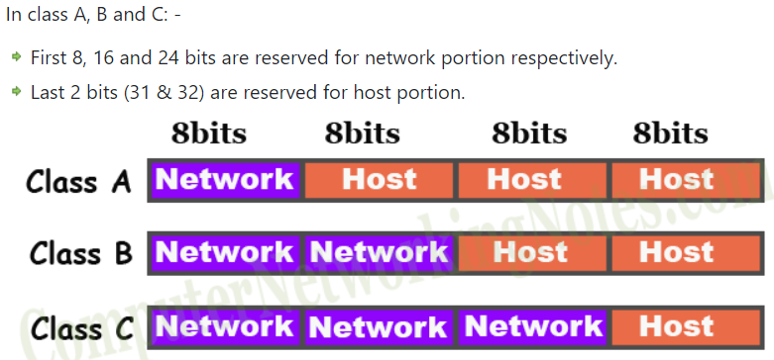

**Subnet mask:**

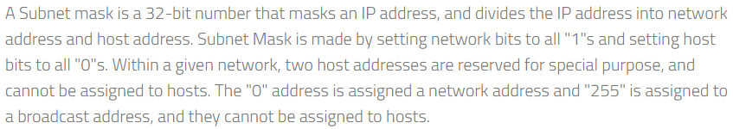

Below are the default subnet mask details in all classes

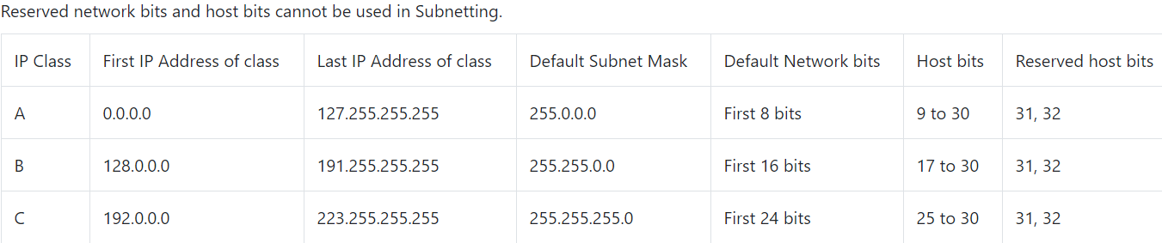

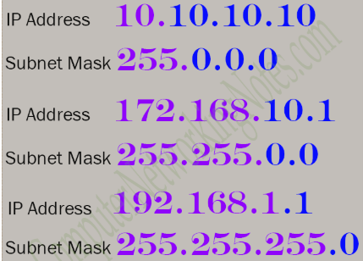

**Subnet mask:**

* SM is 32 bits in which 1’s represents the NID and SID and 0’s represents HID

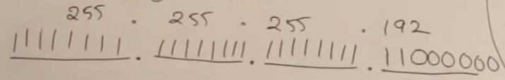

* As above, we can put all 1’s in 24 bits and in host id part, we need to put two 1’s in host part as we have taken 2 bits for SID. Take remaining 6 as 0 for host id part
* We need to convert our ip to decimal and add to SM as below for 200.1.2.130
* If we add any number to 255, we get the same number

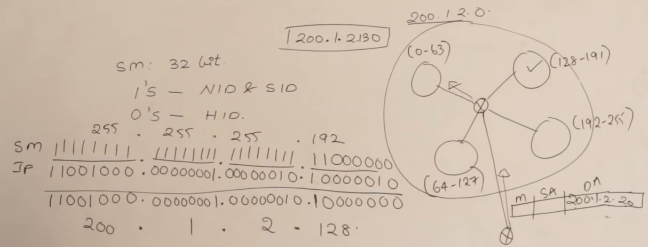

* By giving 200.1.2.130 to subnet mast, we got 200.1.2.128 which belongs to S2
* By giving the ip address and SM, we can find the NID of subnet to which ip belongs to
* So, the router uses SM to check this. For this it is going to make use of something called as routing table
* The interfaces are as below

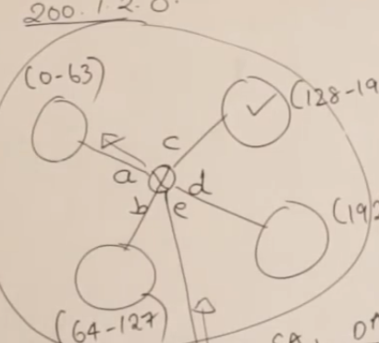

* Whenever the sizes of networks are same, it is called as fixed length subnetting. So, the SM in routing table for all networks will also be same as below
* Sending the packets to correct network is the main intension of routing table

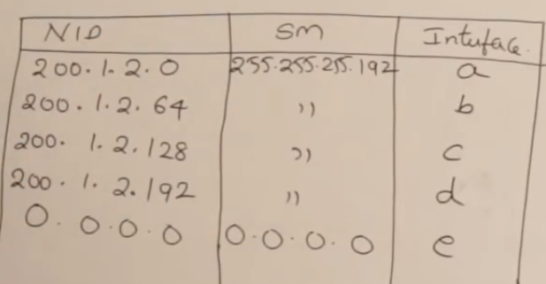

* When request comes, it will add ip to subnet mast and checks the NID to which the IP belongs to, if it doesn’t match with anyone it will send back which is also called default entry
* Sometimes, it might get matched with two entries, in that time, it will choose the longest SM which has more 1’s

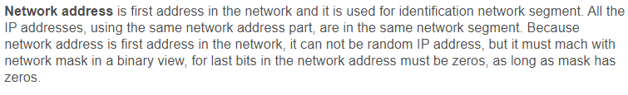

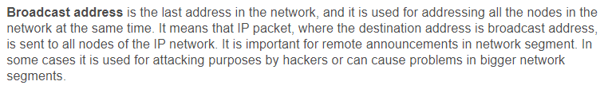

**Subnet mask details:**

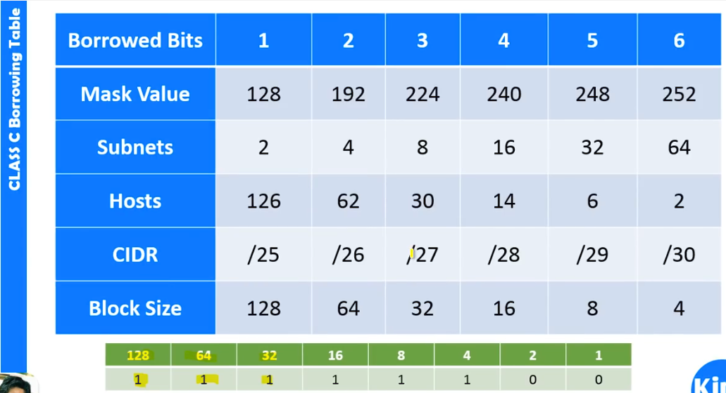

|  |  |  |  |  |  |
| --- | --- | --- | --- | --- | --- |
| **IP/CIDR subnet Mask** | **Host IP Range** | **Subnet Mask** | **Network Ad** | **Broadcast Ad** | **Binary Subnet Mask** |
| 10.0.0.0/1 | 0.0.0.1 - 127.255.255.254 | 128.0.0.0 | 0.0.0.0 | 127.255.255.255 | 10000000000000000000000000000000 |
| 10.0.0.0/2 | 0.0.0.1 - 63.255.255.254 | 192.0.0.0 | 0.0.0.0 | 63.255.255.255 | 11000000000000000000000000000000 |
| 10.0.0.0/3 | 0.0.0.1 - 31.255.255.254 | 224.0.0.0 | 0.0.0.0 | 31.255.255.255 | 11100000000000000000000000000000 |
| 10.0.0.0/4 | 0.0.0.1 - 15.255.255.254 | 240.0.0.0 | 0.0.0.0 | 15.255.255.255 | 11110000000000000000000000000000 |
| 10.0.0.0/5 | 8.0.0.1 - 15.255.255.254 | 248.0.0.0 | 8.0.0.0 | 15.255.255.255 | 11111000000000000000000000000000 |
| 10.0.0.0/6 | 8.0.0.1 - 11.255.255.254 | 252.0.0.0 | 8.0.0.0 | 11.255.255.255 | 11111100000000000000000000000000 |
| 10.0.0.0/7 | 10.0.0.1 - 11.255.255.254 | 254.0.0.0 | 10.0.0.0 | 11.255.255.255 | 11111110000000000000000000000000 |
| 10.0.0.0/8 | 10.0.0.1 - 10.255.255.254 | 255.0.0.0 | 10.0.0.0 | 10.255.255.255 | 11111111000000000000000000000000 |
| 10.0.0.0/9 | 10.0.0.1 - 10.127.255.254 | 255.128.0.0 | 10.0.0.0 | 10.127.255.255 | 11111111100000000000000000000000 |
| 10.0.0.0/10 | 10.0.0.1 - 10.63.255.254 | 255.192.0.0 | 10.0.0.0 | 10.63.255.255 | 11111111110000000000000000000000 |
| 10.0.0.0/11 | 10.0.0.1 - 10.31.255.254 | 255.224.0.0 | 10.0.0.0 | 10.31.255.255 | 11111111111000000000000000000000 |
| 10.0.0.0/12 | 10.0.0.1 - 10.15.255.254 | 255.240.0.0 | 10.0.0.0 | 10.15.255.255 | 11111111111100000000000000000000 |
| 10.0.0.0/13 | 10.0.0.1 - 10.7.255.254 | 255.248.0.0 | 10.0.0.0 | 10.7.255.255 | 11111111111110000000000000000000 |
| 10.0.0.0/14 | 10.0.0.1 - 10.3.255.254 | 255.252.0.0 | 10.0.0.0 | 10.3.255.255 | 11111111111111000000000000000000 |
| 10.0.0.0/15 | 10.0.0.1 - 10.1.255.254 | 255.254.0.0 | 10.0.0.0 | 10.1.255.255 | 11111111111111100000000000000000 |
| 10.0.0.0/16 | 10.0.0.1 - 10.0.255.254 | 255.255.0.0 | 10.0.0.0 | 10.0.255.255 | 11111111111111100000000000000000 |
| 10.0.0.0/17 | 10.0.0.1 - 10.0.127.254 | 255.255.128.0 | 10.0.0.0 | 10.0.127.255 | 11111111111111100000000000000000 |
| 10.0.0.0/18 | 10.0.0.1 - 10.0.63.254 | 255.255.192.0 | 10.0.0.0 | 10.0.63.255 | 11111111111111100000000000000000 |
| 10.0.0.0/19 | 10.0.0.1 - 10.0.31.254 | 255.255.224.0 | 10.0.0.0 | 10.0.31.255 | 11111111111111100000000000000000 |
| 10.0.0.0/20 | 10.0.0.1 - 10.0.15.254 | 255.255.240.0 | 10.0.0.0 | 10.0.15.255 | 11111111111111100000000000000000 |
| 10.0.0.0/21 | 10.0.0.1 - 10.0.7.254 | 255.255.248.0 | 10.0.0.0 | 10.0.7.255 | 11111111111111100000000000000000 |
| 10.0.0.0/22 | 10.0.0.1 - 10.0.3.254 | 255.255.252.0 | 10.0.0.0 | 10.0.3.255 | 11111111111111100000000000000000 |
| 10.0.0.0/23 | 10.0.0.1 - 10.0.1.254 | 255.255.254.0 | 10.0.0.0 | 10.0.1.255 | 11111111111111100000000000000000 |
| 10.0.0.0/24 | 10.0.0.1 - 10.0.0.254 | 255.255.255.0 | 10.0.0.0 | 10.0.0.255 | 11111111111111100000000000000000 |
| 10.0.0.0/25 | 10.0.0.1 - 10.0.0.126 | 255.255.255.128 | 10.0.0.0 | 10.0.0.127 | 11111111111111100000000000000000 |
| 10.0.0.0/26 | 10.0.0.1 - 10.0.0.62 | 255.255.255.192 | 10.0.0.0 | 10.0.0.63 | 11111111111111100000000000000000 |
| 10.0.0.0/27 | 10.0.0.1 - 10.0.0.30 | 255.255.255.224 | 10.0.0.0 | 10.0.0.31 | 11111111111111100000000000000000 |
| 10.0.0.0/28 | 10.0.0.1 - 10.0.0.14 | 255.255.255.240 | 10.0.0.0 | 10.0.0.15 | 11111111111111100000000000000000 |
| 10.0.0.0/29 | 10.0.0.1 - 10.0.0.6 | 255.255.255.248 | 10.0.0.0 | 10.0.0.7 | 11111111111111100000000000000000 |
| 10.0.0.0/30 | 10.0.0.1 - 10.0.0.2 | 255.255.255.252 | 10.0.0.0 | 10.0.0.3 | 11111111111111100000000000000000 |

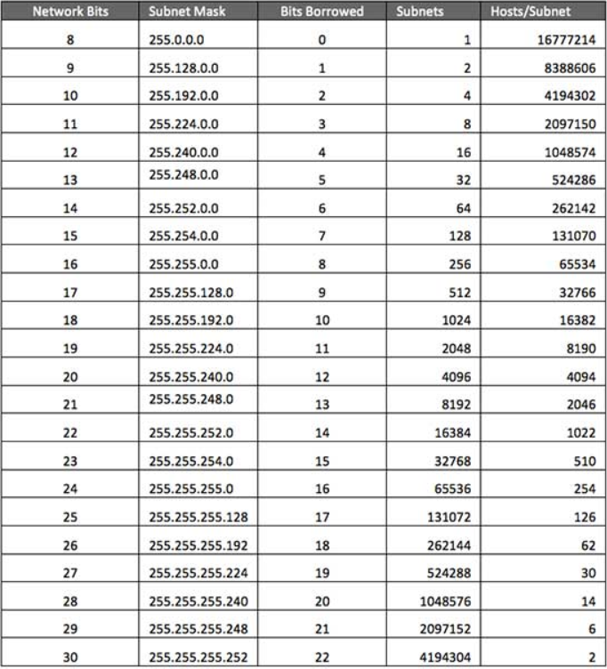

**Dividing IP into multiple subnets:**



Now the IP gets divided till 127 as below

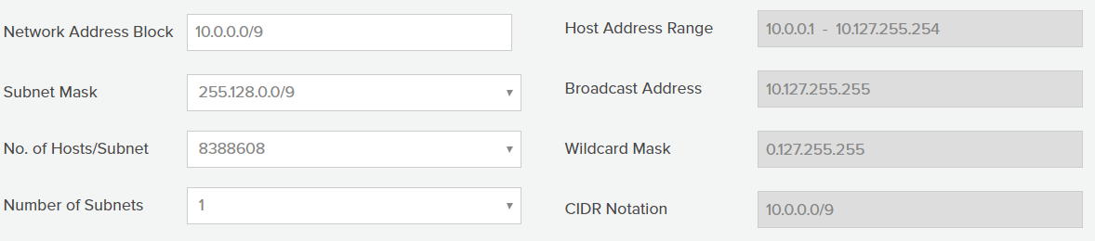

As the first bit value is upto 127. So even if we give anything less than 127 will not be considered as below

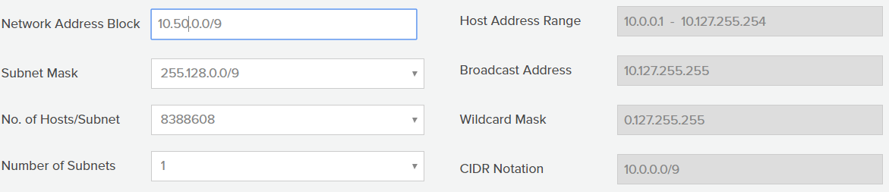

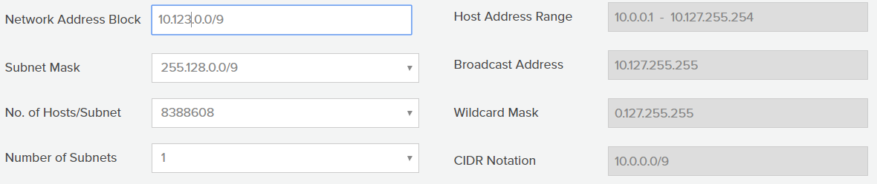

The value gets changes only when we give more than 127 as below

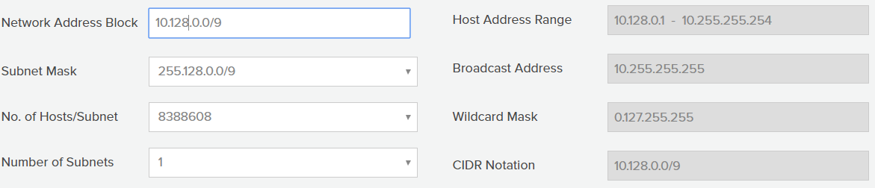

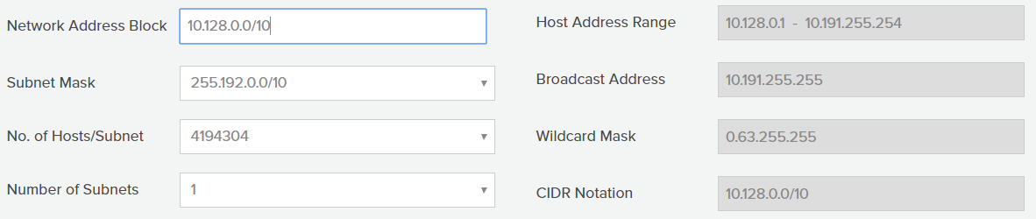

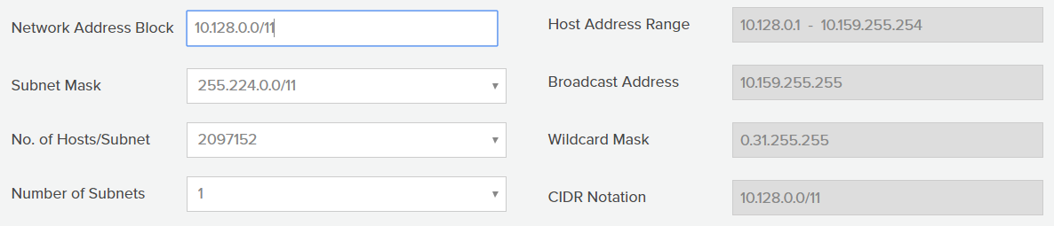

In the above image, we are giving 128 as constant and giving 3 values as contain. 3 means we get 31. So 128+31=159 range of IPs we get

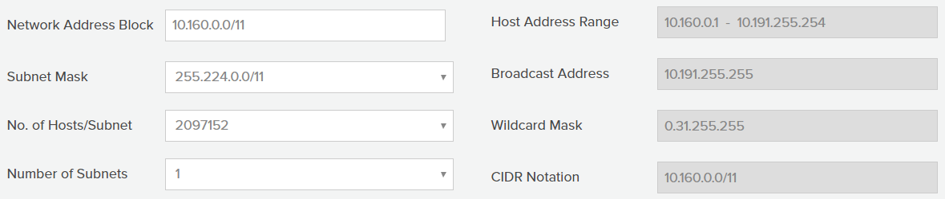

We can divide the IP in this way. We can also divide only using the below values